CHAPTER 4
Animal Kingdom

4 | Animal Kingdom

When you look around, you will observe different animals with different structures and forms. As over a million species of animals have been described till now, the need for classification becomes all the more important. The classification also helps in assigning a systematic position to newly described species. This chapter runs in two parts: 4.1 Basis of Classification and 4.2 Classification of Animals.
4.1 | Basis of Classification

Inspite of differences in structure and form of different animals, there are fundamental features common to various individuals in relation to the arrangement of cells, body symmetry, nature of coelom, and patterns of digestive, circulatory or reproductive systems. These features are used as the basis of animal classification and some of them are discussed here.
4.1.1 | Levels of Organisation

Though all members of Animalia are multicellular, all of them do not exhibit the same pattern of organisation of cells.
• Cellular level: in sponges, the cells are arranged as loose cell aggregates. Some division of labour (activities) occurs among the cells.
• Tissue level: in coelenterates, the arrangement of cells is more complex. Cells performing the same function are arranged into tissues.
• Organ level: exhibited by Platyhelminthes and other higher phyla, where tissues are grouped together to form organs, each specialised for a particular function.
• Organ system level: in Annelids, Arthropods, Molluscs, Echinoderms and Chordates, organs have associated to form functional systems, each system concerned with a specific physiological function.
Organ systems in different groups of animals exhibit various patterns of complexities. Two examples are the digestive and the circulatory systems:
• The digestive system in Platyhelminthes has only a single opening to the outside of the body that serves as both mouth and anus, and is hence called incomplete. A complete digestive system has two openings, mouth and anus.
• The circulatory system is of two types: (i) open type in which the blood is pumped out of the heart and the cells and tissues are directly bathed in it; (ii) closed type in which the blood is circulated through a series of vessels of varying diameters (arteries, veins and capillaries).
4.1.2 | Symmetry

Animals can be categorised on the basis of their symmetry.
• Asymmetry: sponges are mostly asymmetrical, i.e., any plane that passes through the centre does not divide them into equal halves.
• Radial symmetry: when any plane passing through the central axis of the body divides the organism into two identical halves. Coelenterates, ctenophores and echinoderms have this kind of body plan (Figure 4.1a).
• Bilateral symmetry: animals like annelids, arthropods, etc., where the body can be divided into identical left and right halves in only one plane (Figure 4.1b).
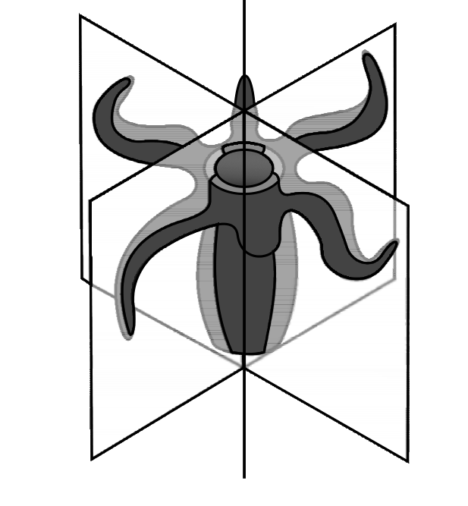  Fig. 4.1(a) - Radial symmetry. | 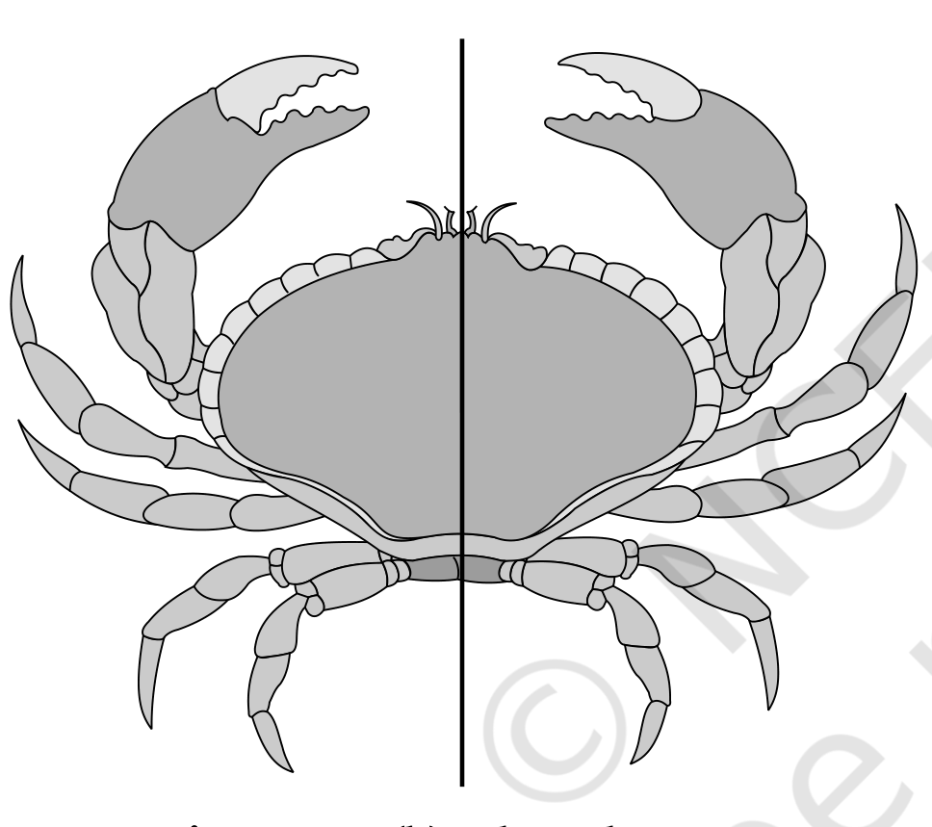  Fig. 4.1(b) - Bilateral symmetry.

4.1.3 | Diploblastic and Triploblastic Organisation

• Diploblastic animals: those in which the cells are arranged in two embryonic layers, an external ectoderm and an internal endoderm, e.g., coelenterates. An undifferentiated layer, mesoglea, is present in between the ectoderm and the endoderm (Figure 4.2a).
• Triploblastic animals: those in which the developing embryo has a third germinal layer, mesoderm, in between the ectoderm and endoderm (platyhelminthes to chordates, Figure 4.2b).
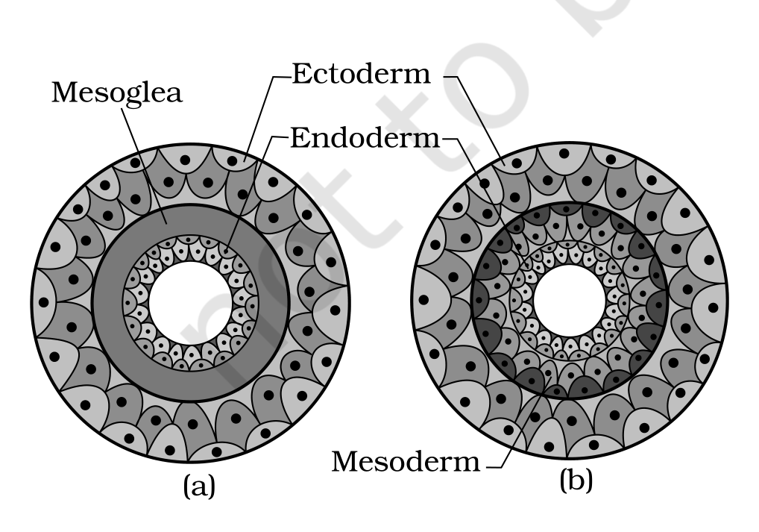
Fig. 4.2 - Showing germinal layers : (a) Diploblastic (b) Triploblastic. Labels: Ectoderm, Mesoglea, Endoderm and Mesoderm.
4.1.4 | Coelom

Presence or absence of a cavity between the body wall and the gut wall is very important in classification. The body cavity, which is lined by mesoderm, is called coelom.
• Coelomates: animals possessing coelom, e.g., annelids, molluscs, arthropods, echinoderms, hemichordates and chordates (Figure 4.3a).
• Pseudocoelomates: in some animals the body cavity is not lined by mesoderm; instead the mesoderm is present as scattered pouches in between the ectoderm and endoderm. Such a body cavity is called pseudocoelom, e.g., aschelminthes (Figure 4.3b).
• Acoelomates: animals in which the body cavity is absent, e.g., platyhelminthes (Figure 4.3c).
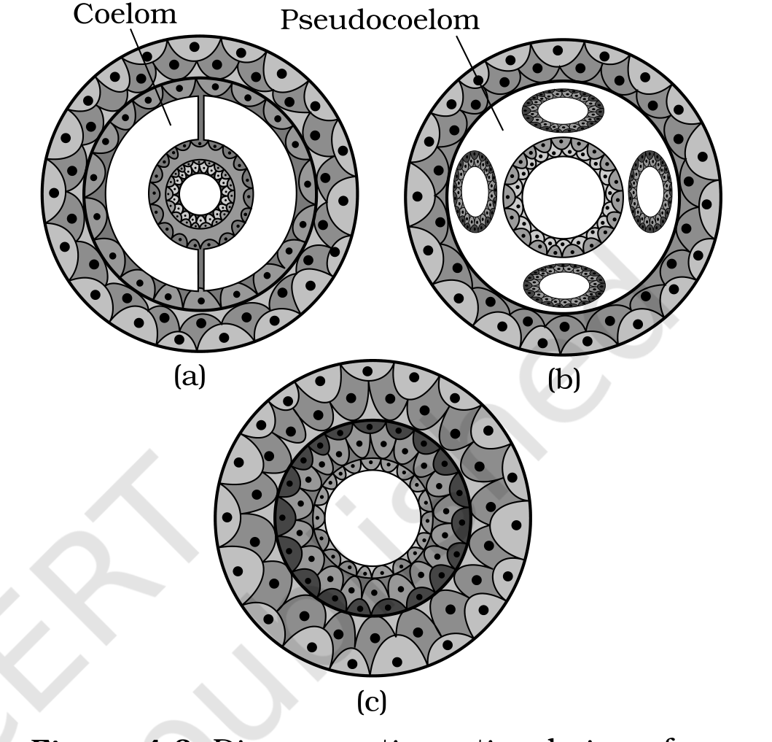
Fig. 4.3 - Diagrammatic sectional view of : (a) Coelomate (b) Pseudocoelomate (c) Acoelomate. Labels: Coelom and Pseudocoelom.
4.1.5 | Segmentation

In some animals, the body is externally and internally divided into segments with a serial repetition of at least some organs. For example, in earthworm, the body shows this pattern called metameric segmentation and the phenomenon is known as metamerism.
4.1.6 | Notochord

Notochord is a mesodermally derived rod-like structure formed on the dorsal side during embryonic development in some animals. Animals with notochord are called chordates and those animals which do not form this structure are called non-chordates, e.g., porifera to echinoderms.
4.2 | Classification of Animals

The broad classification of Animalia, based on common fundamental features as mentioned in the preceding sections, is given in Figure 4.4. The important characteristic features of the different phyla are described in the sections that follow.
• The classification chart branches the Kingdom Animalia (multicellular) by Levels of Organisation, then by Symmetry, and then by Body Cavity or Coelom, ending in the Phylum leaves. From the cellular level branch come Porifera (mostly asymmetrical). From the Tissue/Organ/Organ system levels branch, by Radial symmetry, come Coelenterata (Cnidaria) and Ctenophora.
• Under Bilateral symmetry the animals are grouped by body cavity: Without body cavity (acoelomates) gives Platyhelminthes; With false coelom (pseudocoelomates) gives Aschelminthes; and With true coelom (coelomates) gives Annelida, Arthropoda, Mollusca, Echinodermata, Hemichordata and Chordata.
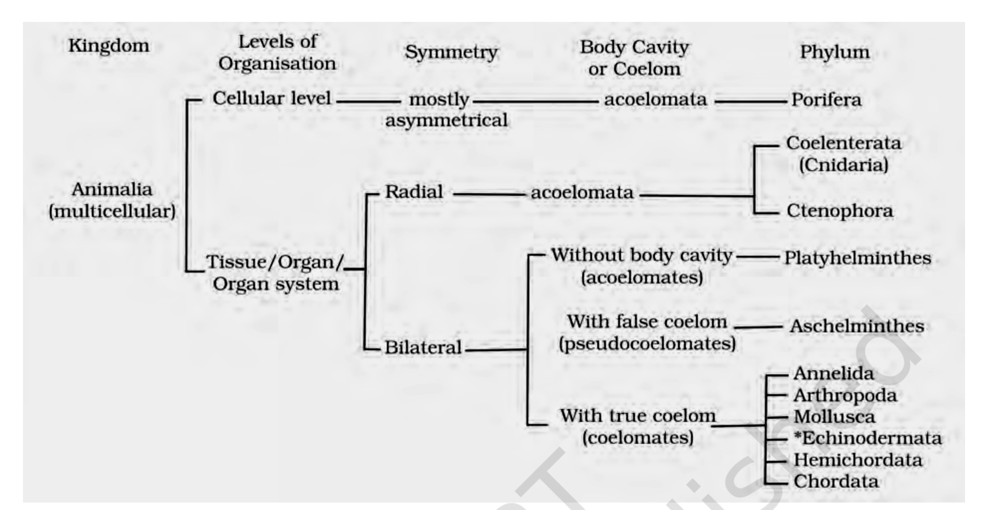
Fig. 4.4 - Broad classification of Kingdom Animalia based on common fundamental features.
[NOTE] Echinodermata exhibits radial or bilateral symmetry depending on the stage.

4.2.1 | Phylum - Porifera

• Members of this phylum are commonly known as sponges. They are generally marine and mostly asymmetrical animals (Figure 4.5). These are primitive multicellular animals and have cellular level of organisation.
• Sponges have a water transport or canal system. This pathway of water transport is helpful in food gathering, respiratory exchange and removal of waste.
1 | Water enters through minute pores (ostia) in the body wall.
2 | It passes into a central cavity, the spongocoel.
3 | Water goes out through the osculum.

• Choanocytes or collar cells, which are flagellated, line the spongocoel and the canals. Digestion is intracellular. The body is supported by a skeleton made up of spicules or spongin fibres.
• Sexes are not separate (hermaphrodite), i.e., eggs and sperms are produced by the same individual. Sponges reproduce asexually by fragmentation and sexually by formation of gametes. Fertilisation is internal and development is indirect, having a larval stage which is morphologically distinct from the adult.
• Examples: Sycon (Scypha), Spongilla (Fresh water sponge) and Euspongia (Bath sponge).
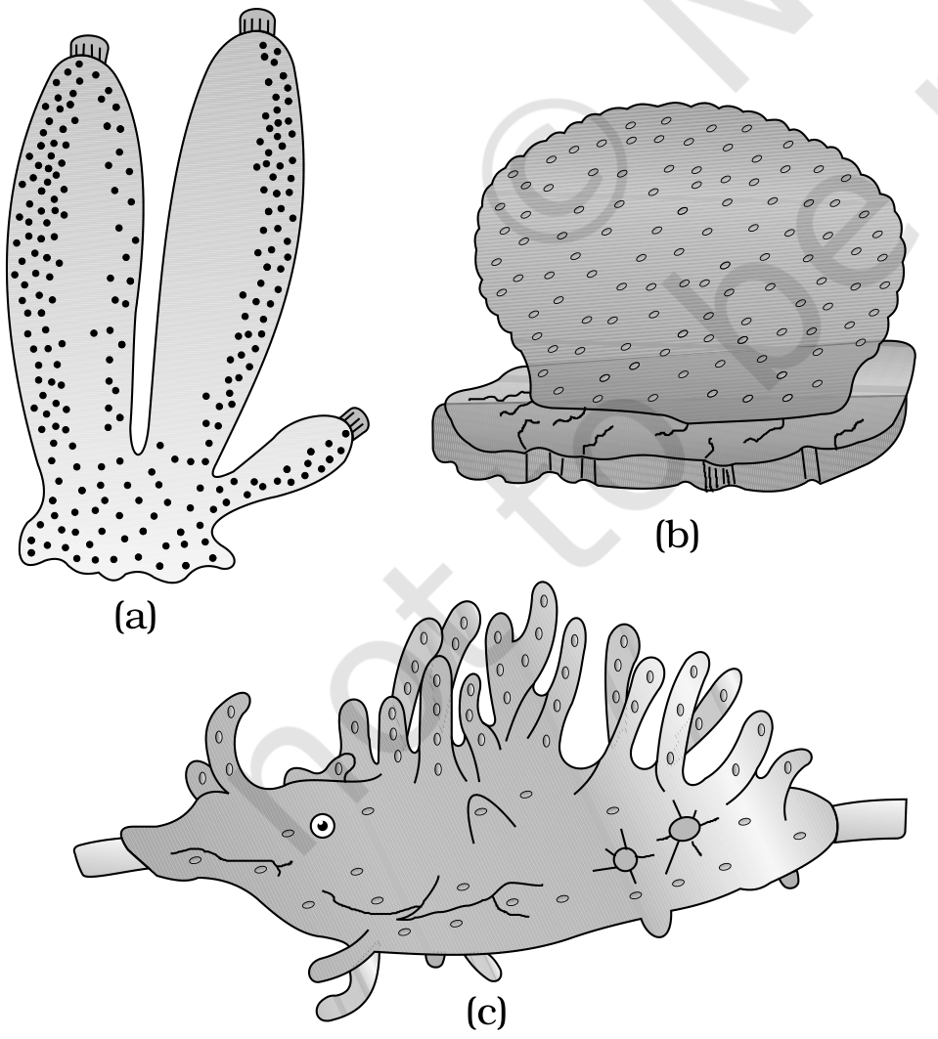
Fig. 4.5 - Examples of Porifera : (a) Sycon (b) Euspongia (c) Spongilla.
4.2.2 | Phylum - Coelenterata (Cnidaria)

• They are aquatic, mostly marine, sessile or free-swimming, radially symmetrical animals (Figure 4.6). The name cnidaria is derived from the cnidoblasts or cnidocytes (which contain the stinging capsules or nematocysts) present on the tentacles and the body. Cnidoblasts are used for anchorage, defense and for the capture of prey (Figure 4.7).
• Cnidarians exhibit tissue level of organisation and are diploblastic. They have a central gastro-vascular cavity with a single opening, mouth on hypostome. Digestion is extracellular and intracellular. Some cnidarians, e.g., corals, have a skeleton composed of calcium carbonate.
• Cnidarians exhibit two basic body forms called polyp and medusa (Figure 4.6). The former is a sessile and cylindrical form like Hydra, Adamsia, etc., whereas the latter is umbrella-shaped and free-swimming like Aurelia or jelly fish.
• Those cnidarians which exist in both forms exhibit alternation of generations (Metagenesis), i.e., polyps produce medusae asexually and medusae form the polyps sexually (e.g., Obelia).
• Examples: Physalia (Portuguese man-of-war), Adamsia (Sea anemone), Pennatula (Sea-pen), Gorgonia (Sea-fan) and Meandrina (Brain coral).
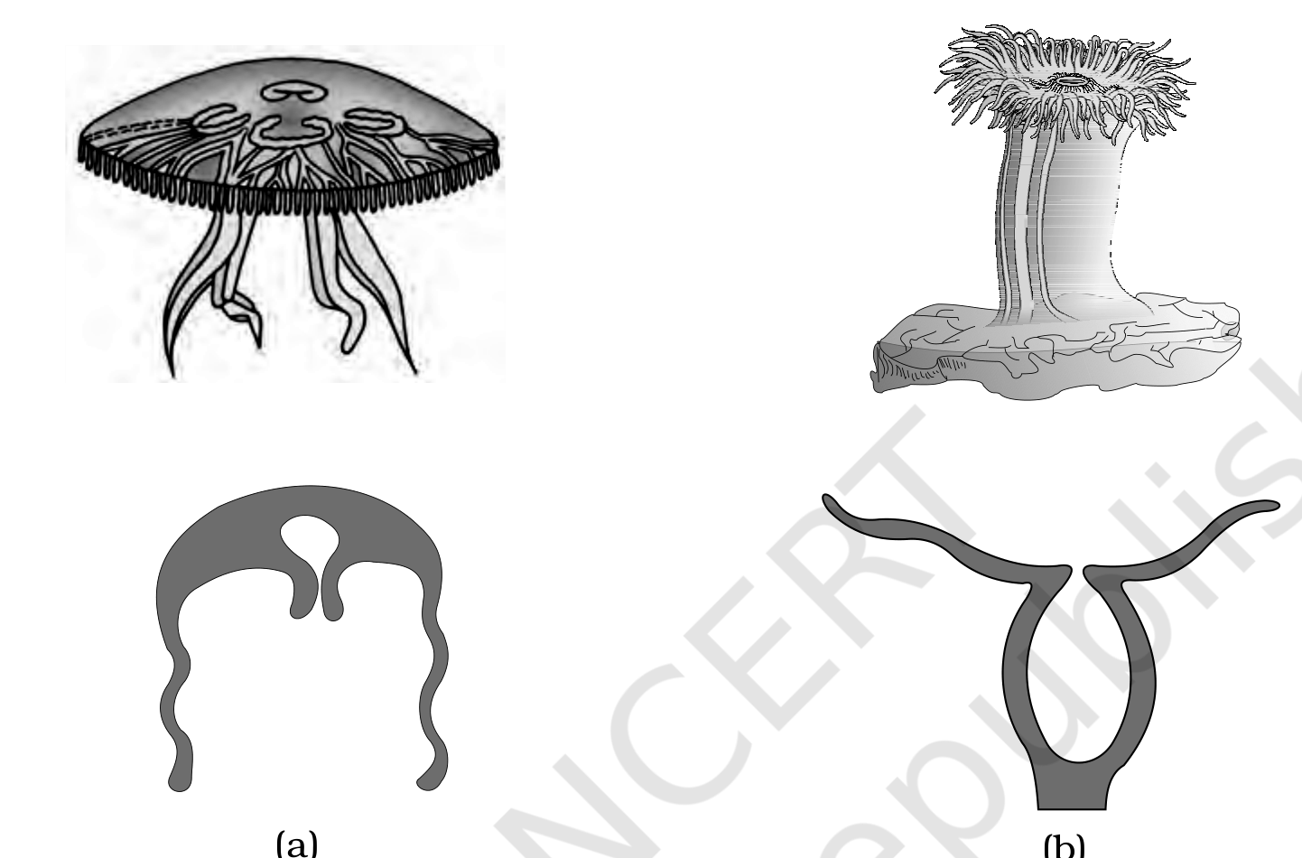  Fig. 4.6 - Examples of Coelenterata indicating outline of their body form : (a) Aurelia (Medusa) (b) Adamsia (Polyp). | 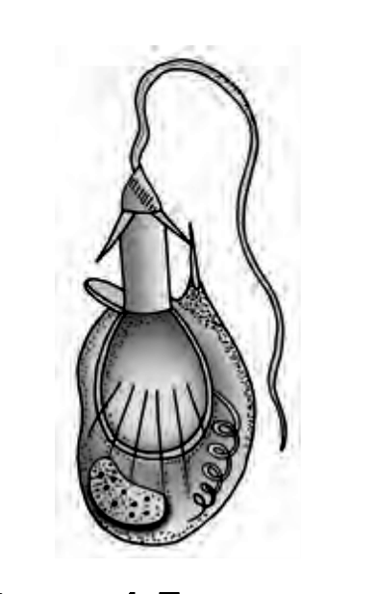  Fig. 4.7 - Diagrammatic view of Cnidoblast.

4.2.3 | Phylum - Ctenophora

• Ctenophores, commonly known as sea walnuts or comb jellies, are exclusively marine, radially symmetrical, diploblastic organisms with tissue level of organisation. The body bears eight external rows of ciliated comb plates, which help in locomotion (Figure 4.8).
• Digestion is both extracellular and intracellular. Bioluminescence (the property of a living organism to emit light) is well-marked in ctenophores.
• Sexes are not separate. Reproduction takes place only by sexual means. Fertilisation is external with indirect development.
• Examples: Pleurobrachia and Ctenoplana.
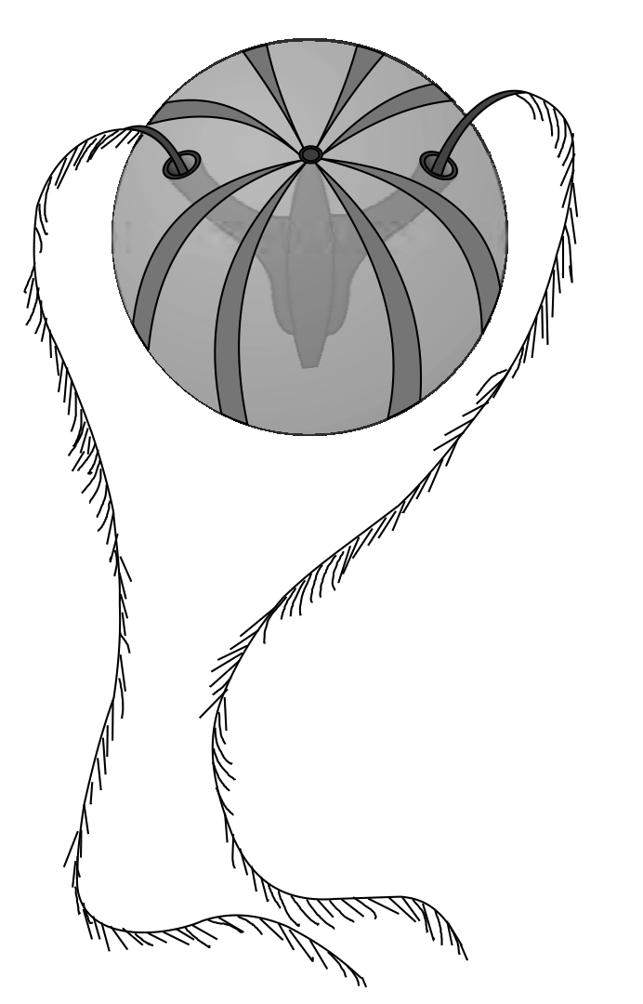
Fig. 4.8 - Example of Ctenophora (Pleurobrachia).
4.2.4 | Phylum - Platyhelminthes

• They have a dorso-ventrally flattened body, hence are called flatworms (Figure 4.9). These are mostly endoparasites found in animals including human beings. Flatworms are bilaterally symmetrical, triploblastic and acoelomate animals with organ level of organisation.
• Hooks and suckers are present in the parasitic forms. Some of them absorb nutrients from the host directly through their body surface. Specialised cells called flame cells help in osmoregulation and excretion.
• Sexes are not separate. Fertilisation is internal and development is through many larval stages. Some members like Planaria possess high regeneration capacity.
• Examples: Taenia (Tapeworm), Fasciola (Liver fluke).
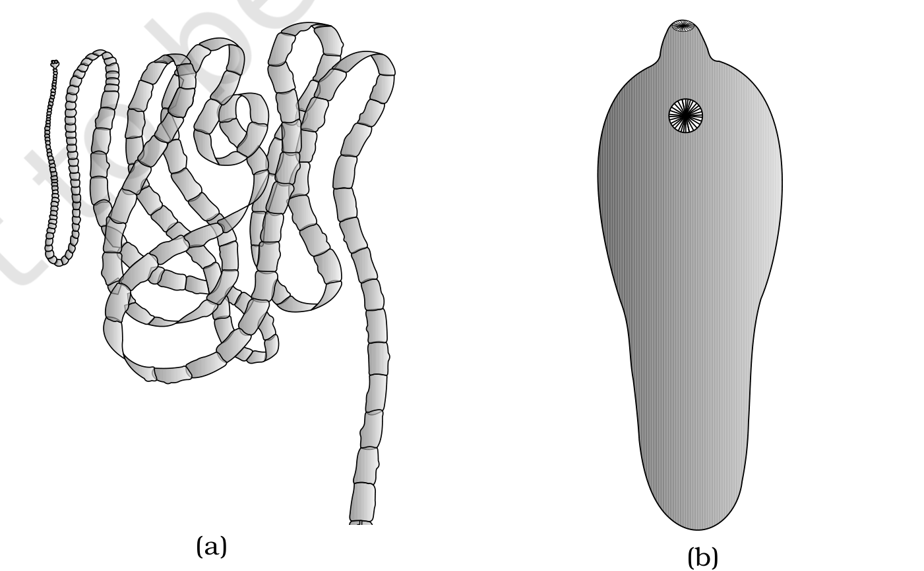
Fig. 4.9 - Examples of Platyhelminthes : (a) Tape worm (b) Liver fluke.
4.2.5 | Phylum - Aschelminthes

• The body of the aschelminthes is circular in cross-section, hence the name roundworms (Figure 4.10). They may be free-living, aquatic and terrestrial or parasitic in plants and animals. Roundworms have organ-system level of body organisation.
• They are bilaterally symmetrical, triploblastic and pseudocoelomate animals. Alimentary canal is complete with a well-developed muscular pharynx. An excretory tube removes body wastes from the body cavity through the excretory pore.
• Sexes are separate (dioecious), i.e., males and females are distinct. Often females are longer than males. Fertilisation is internal and development may be direct (the young ones resemble the adult) or indirect.
• Examples: Ascaris (Roundworm), Wuchereria (Filaria worm), Ancylostoma (Hookworm).
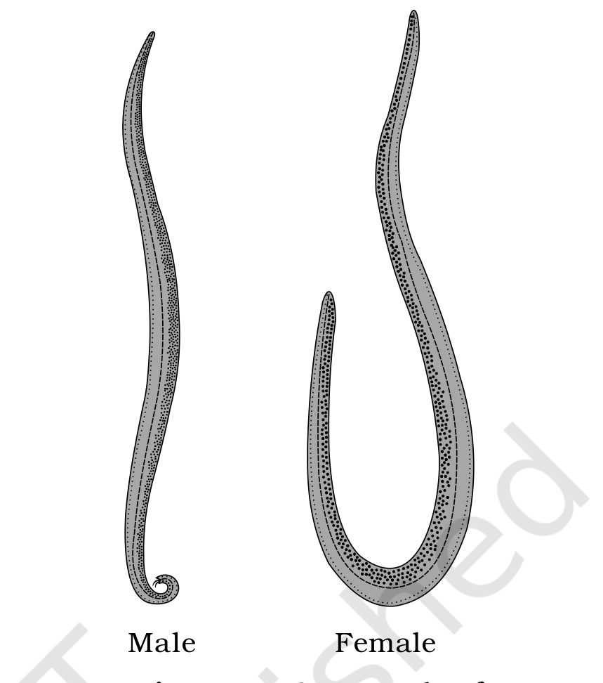
Fig. 4.10 - Example of Aschelminthes : Roundworm. Labels: Male and Female.
4.2.6 | Phylum - Annelida

• They may be aquatic (marine and fresh water) or terrestrial; free-living, and sometimes parasitic. They exhibit organ-system level of body organisation and bilateral symmetry. They are triploblastic, metamerically segmented and coelomate animals.
• Their body surface is distinctly marked out into segments or metameres and, hence, the phylum name Annelida (Latin, annulus : little ring) (Figure 4.11). They possess longitudinal and circular muscles which help in locomotion. Aquatic annelids like Nereis possess lateral appendages, parapodia, which help in swimming.
• A closed circulatory system is present. Nephridia (sing. nephridium) help in osmoregulation and excretion. Neural system consists of paired ganglia (sing. ganglion) connected by lateral nerves to a double ventral nerve cord.
• Nereis, an aquatic form, is dioecious, but earthworms and leeches are monoecious. Reproduction is sexual.
• Examples: Nereis, Pheretima (Earthworm) and Hirudinaria (Blood sucking leech).
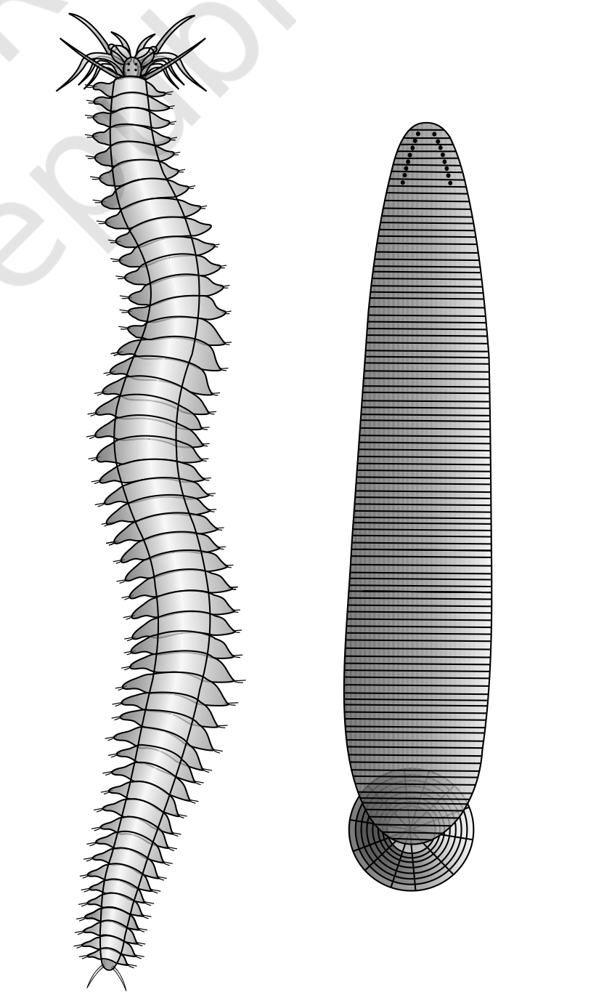
Fig. 4.11 - Examples of Annelida : (a) Nereis (b) Hirudinaria.
4.2.7 | Phylum - Arthropoda

• This is the largest phylum of Animalia which includes insects. Over two-thirds of all named species on earth are arthropods (Figure 4.12). They have organ-system level of organisation.
• They are bilaterally symmetrical, triploblastic, segmented and coelomate animals. The body of arthropods is covered by chitinous exoskeleton. The body consists of head, thorax and abdomen. They have jointed appendages (arthros-joint, poda-appendages).
• Respiratory organs are gills, book gills, book lungs or tracheal system. Circulatory system is of open type. Sensory organs like antennae, eyes (compound and simple), statocysts or balancing organs are present. Excretion takes place through malpighian tubules.
• They are mostly dioecious. Fertilisation is usually internal. They are mostly oviparous. Development may be direct or indirect.
• Examples: Economically important insects - Apis (Honey bee), Bombyx (Silkworm), Laccifer (Lac insect); Vectors - Anopheles, Culex and Aedes (Mosquitoes); Gregarious pest - Locusta (Locust); Living fossil - Limulus (King crab).
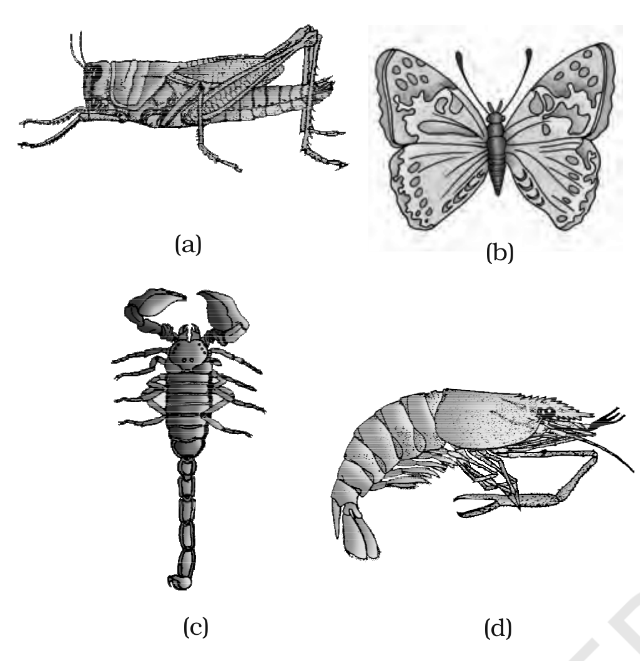
Fig. 4.12 - Examples of Arthropoda : (a) Locust (b) Butterfly (c) Scorpion (d) Prawn.
4.2.8 | Phylum - Mollusca

• This is the second largest animal phylum (Figure 4.13). Molluscs are terrestrial or aquatic (marine or fresh water) having an organ-system level of organisation. They are bilaterally symmetrical, triploblastic and coelomate animals.
• Body is covered by a calcareous shell and is unsegmented with a distinct head, muscular foot and visceral hump. A soft and spongy layer of skin forms a mantle over the visceral hump. The space between the hump and the mantle is called the mantle cavity in which feather-like gills are present. They have respiratory and excretory functions.
• The anterior head region has sensory tentacles. The mouth contains a file-like rasping organ for feeding, called radula. They are usually dioecious and oviparous with indirect development.
• Examples: Pila (Apple snail), Pinctada (Pearl oyster), Sepia (Cuttlefish), Loligo (Squid), Octopus (Devil fish), Aplysia (Sea-hare), Dentalium (Tusk shell) and Chaetopleura (Chiton).
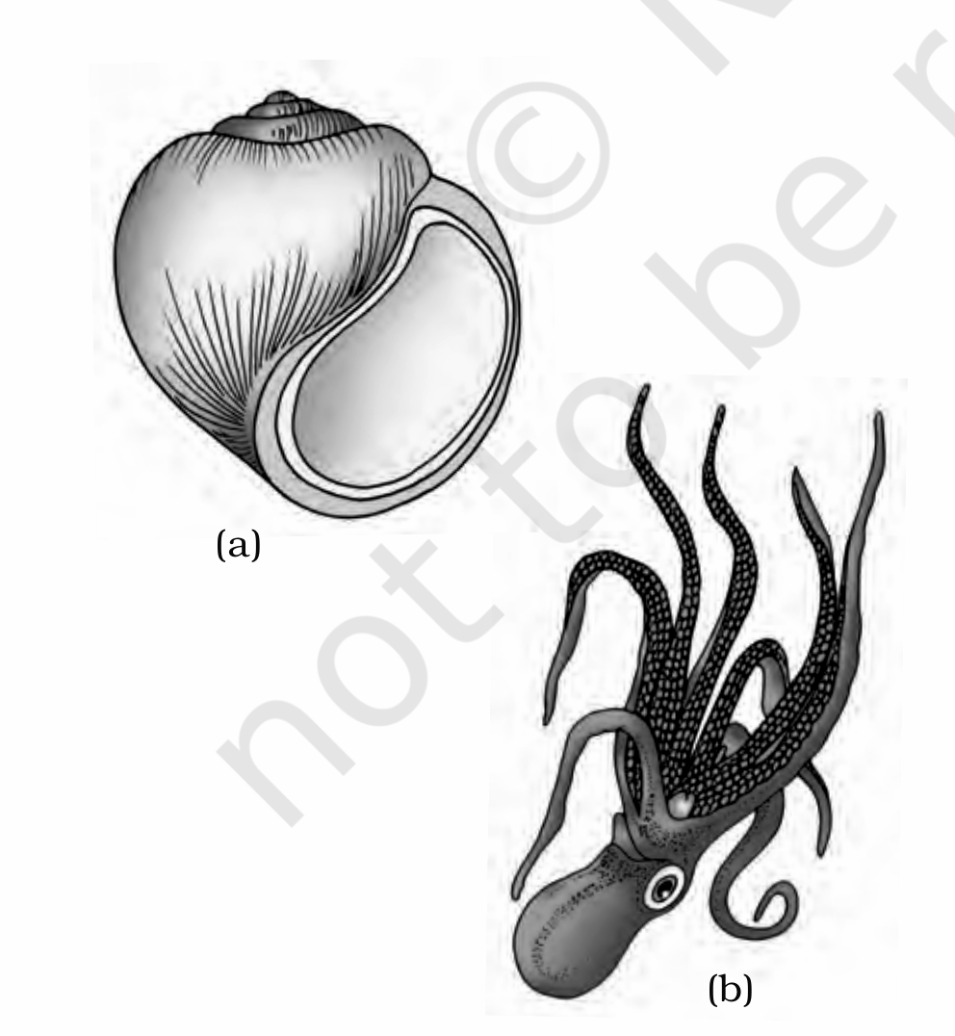
Fig. 4.13 - Examples of Mollusca : (a) Pila (b) Octopus.
4.2.9 | Phylum - Echinodermata

• These animals have an endoskeleton of calcareous ossicles and, hence, the name Echinodermata (Spiny bodied, Figure 4.14). All are marine with organ-system level of organisation.
• The adult echinoderms are radially symmetrical but larvae are bilaterally symmetrical. They are triploblastic and coelomate animals. Digestive system is complete with mouth on the lower (ventral) side and anus on the upper (dorsal) side.
• The most distinctive feature of echinoderms is the presence of water vascular system which helps in locomotion, capture and transport of food and respiration. An excretory system is absent.
• Sexes are separate. Reproduction is sexual. Fertilisation is usually external. Development is indirect with free-swimming larva.
• Examples: Asterias (Star fish), Echinus (Sea urchin), Antedon (Sea lily), Cucumaria (Sea cucumber) and Ophiura (Brittle star).
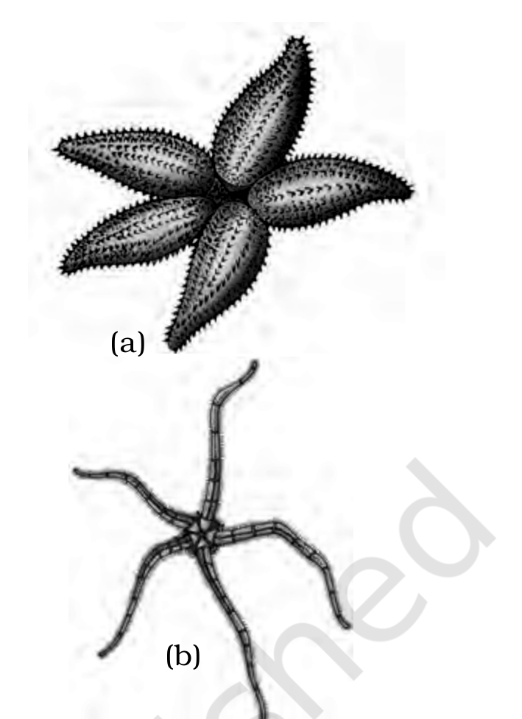
Fig. 4.14 - Examples of Echinodermata : (a) Asterias (b) Ophiura.
4.2.10 | Phylum - Hemichordata

• Hemichordata was earlier considered as a sub-phylum under phylum Chordata. But now it is placed as a separate phylum under non-chordata. Hemichordates have a rudimentary structure in the collar region called stomochord, a structure similar to notochord.
• This phylum consists of a small group of worm-like marine animals with organ-system level of organisation. They are bilaterally symmetrical, triploblastic and coelomate animals. The body is cylindrical and is composed of an anterior proboscis, a collar and a long trunk (Figure 4.15).
• Circulatory system is of open type. Respiration takes place through gills. Excretory organ is proboscis gland. Sexes are separate. Fertilisation is external. Development is indirect.
• Examples: Balanoglossus and Saccoglossus.
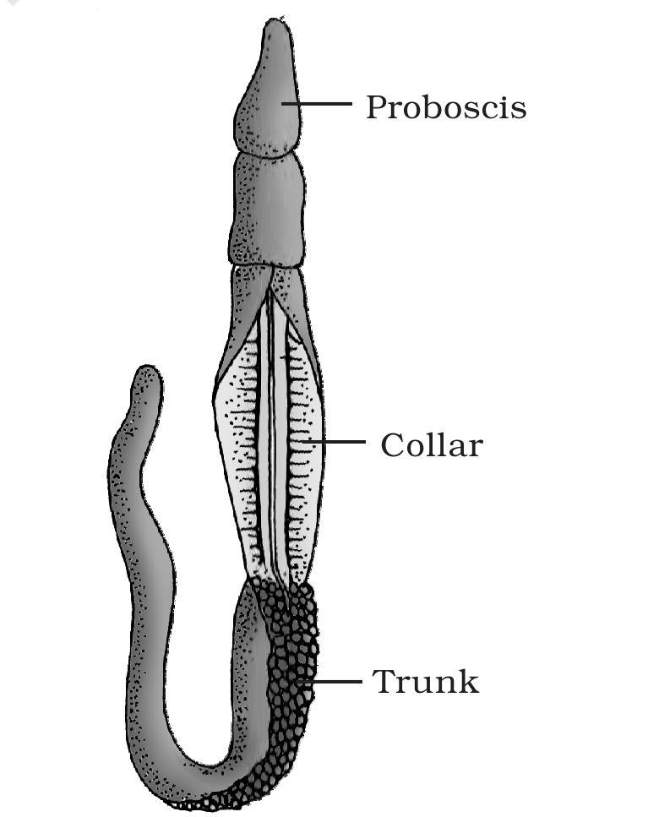
Fig. 4.15 - Balanoglossus. Labels: Proboscis, Collar and Trunk.
4.2.11 | Phylum - Chordata

• Animals belonging to phylum Chordata are fundamentally characterised by the presence of a notochord, a dorsal hollow nerve cord and paired pharyngeal gill slits (Figure 4.16).
• These are bilaterally symmetrical, triploblastic, coelomate with organ-system level of organisation.
• They possess a post-anal part (tail) and a closed circulatory system. Table 4.1 presents a comparison of salient features of chordates and non-chordates.
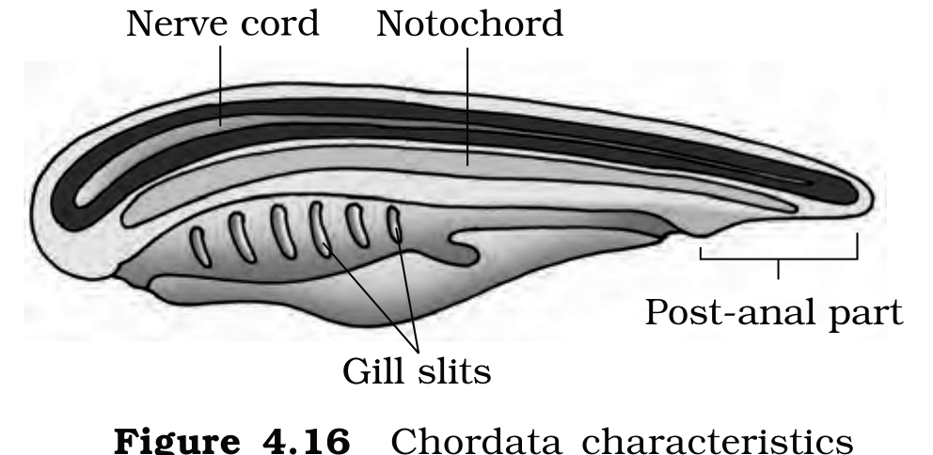
Fig. 4.16 - Chordata characteristics. Labels: Nerve cord, Notochord, Post-anal part and Gill slits.
• Phylum Chordata is divided into three subphyla: Urochordata or Tunicata, Cephalochordata and Vertebrata.
• Subphyla Urochordata and Cephalochordata are often referred to as protochordates (Figure 4.17) and are exclusively marine. In Urochordata, notochord is present only in the larval tail, while in Cephalochordata it extends from head to tail region and is persistent throughout their life.
• Examples: Urochordata - Ascidia, Salpa, Doliolum; Cephalochordata - Branchiostoma (Amphioxus or Lancelet).
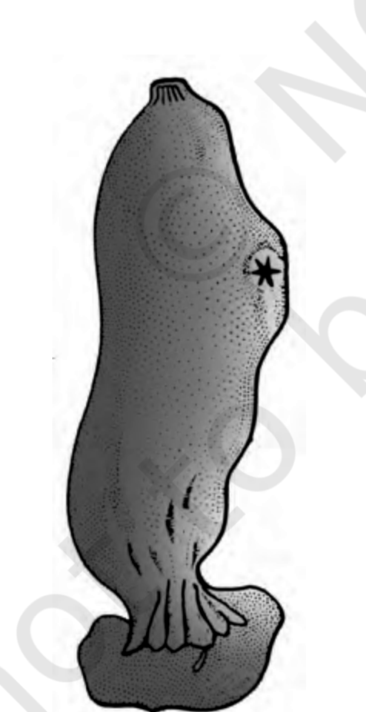
Fig. 4.17 - Ascidia (a urochordate protochordate).
• The members of subphylum Vertebrata possess notochord during the embryonic period. The notochord is replaced by a cartilaginous or bony vertebral column in the adult. Thus all vertebrates are chordates but all chordates are not vertebrates.
• Besides the basic chordate characters, vertebrates have a ventral muscular heart with two, three or four chambers, kidneys for excretion and osmoregulation and paired appendages which may be fins or limbs.
TABLE 4.1 Comparison of Chordates and Non-chordates
Chordates | Non-chordates
Notochord present. | Notochord absent.
Central nervous system is dorsal, hollow and single. | Central nervous system is ventral, solid and double.
Pharynx perforated by gill slits. | Gill slits are absent.
Heart is ventral. | Heart is dorsal (if present).
A post-anal part (tail) is present. | Post-anal tail is absent.

The subphylum Vertebrata is further divided as follows:
• Subphylum Vertebrata is split into two divisions on the basis of jaws: Division Agnatha (lacks jaw) and Division Gnathostomata (bears jaw).
- Division Agnatha (lacks jaw) includes a single Class - Cyclostomata.
- Division Gnathostomata (bears jaw) is divided into two super classes: Super Class Pisces (bear fins) and Super Class Tetrapoda (bear limbs).
- Super Class Pisces (bear fins): Classes Chondrichthyes and Osteichthyes.
- Super Class Tetrapoda (bear limbs): Classes Amphibia, Reptilia, Aves and Mammals.
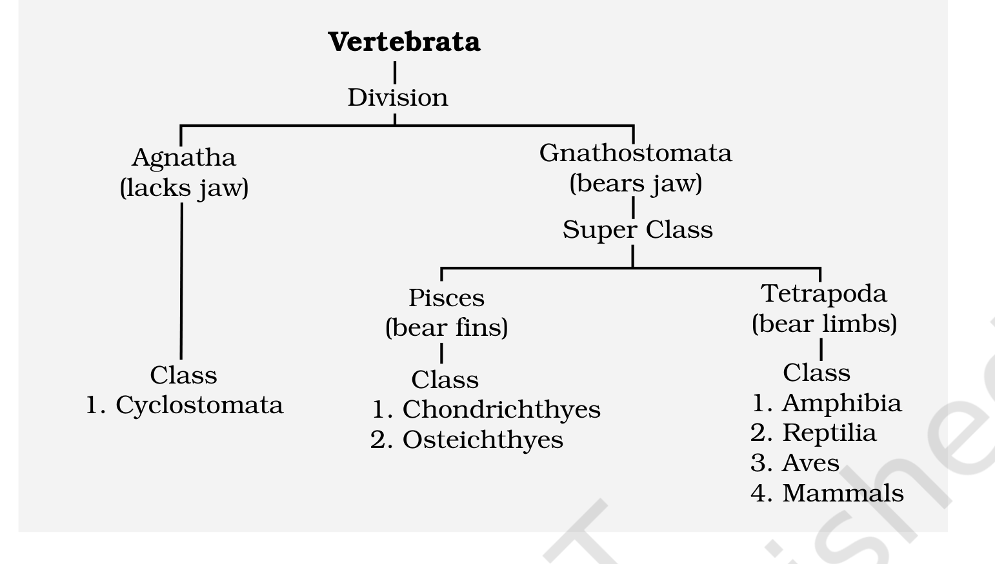
Classification chart of subphylum Vertebrata - Divisions Agnatha and Gnathostomata; Super Class Pisces and Tetrapoda; Classes Cyclostomata, Chondrichthyes, Osteichthyes, Amphibia, Reptilia, Aves and Mammals.
4.2.11.1 | Class - Cyclostomata

• All living members of the class Cyclostomata are ectoparasites on some fishes. They are the most primitive chordates.
• They have an elongated body bearing 6-15 pairs of gill slits for respiration. Cyclostomes have a sucking and circular mouth without jaws (Fig. 4.18).
• Their body is devoid of scales and paired fins. Cranium and vertebral column are cartilaginous. Circulation is of closed type.
• Cyclostomes are marine but migrate for spawning to fresh water. After spawning, within a few days, they die. Their larvae, after metamorphosis, return to the ocean.
• Examples: Petromyzon (Lamprey) and Myxine (Hagfish).
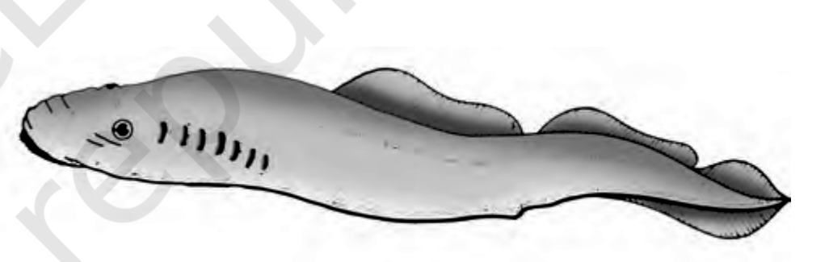
Fig. 4.18 - A jawless vertebrate : Petromyzon.
4.2.11.2 | Class - Chondrichthyes

• They are marine animals with streamlined body and have cartilaginous endoskeleton (Figure 4.19). Mouth is located ventrally. Notochord is persistent throughout life.
• Gill slits are separate and without operculum (gill cover). The skin is tough, containing minute placoid scales. Teeth are modified placoid scales which are backwardly directed. Their jaws are very powerful.
• These animals are predaceous. Due to the absence of air bladder, they have to swim constantly to avoid sinking. Heart is two-chambered (one auricle and one ventricle).
• Some of them have electric organs (e.g., Torpedo) and some possess poison sting (e.g., Trygon). They are cold-blooded (poikilothermous) animals, i.e., they lack the capacity to regulate their body temperature.
• Sexes are separate. In males pelvic fins bear claspers. They have internal fertilisation and many of them are viviparous.
• Examples: Scoliodon (Dog fish), Pristis (Saw fish), Carcharodon (Great white shark), Trygon (Sting ray).
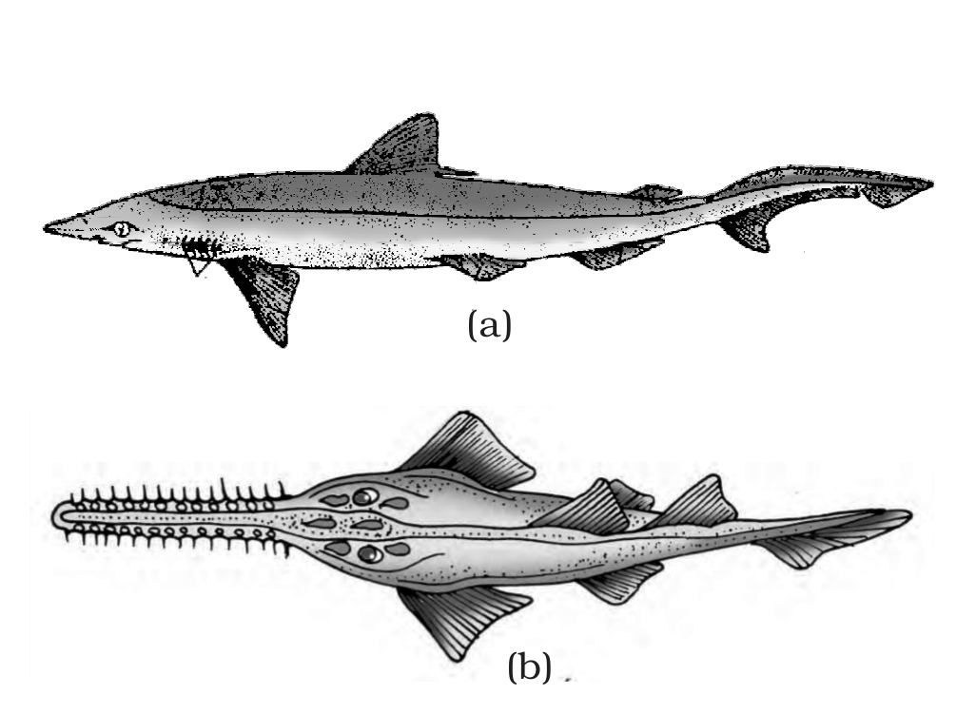
Fig. 4.19 - Cartilaginous fishes : (a) Scoliodon (b) Pristis.
4.2.11.3 | Class - Osteichthyes

• It includes both marine and fresh water fishes with bony endoskeleton. Their body is streamlined. Mouth is mostly terminal (Figure 4.20).
• They have four pairs of gills which are covered by an operculum on each side. Skin is covered with cycloid/ctenoid scales. Air bladder is present which regulates buoyancy.
• Heart is two-chambered (one auricle and one ventricle). They are cold-blooded animals. Sexes are separate. Fertilisation is usually external. They are mostly oviparous and development is direct.
• Examples: Marine - Exocoetus (Flying fish), Hippocampus (Sea horse); Freshwater - Labeo (Rohu), Catla (Katla), Clarias (Magur); Aquarium - Betta (Fighting fish), Pterophyllum (Angel fish).
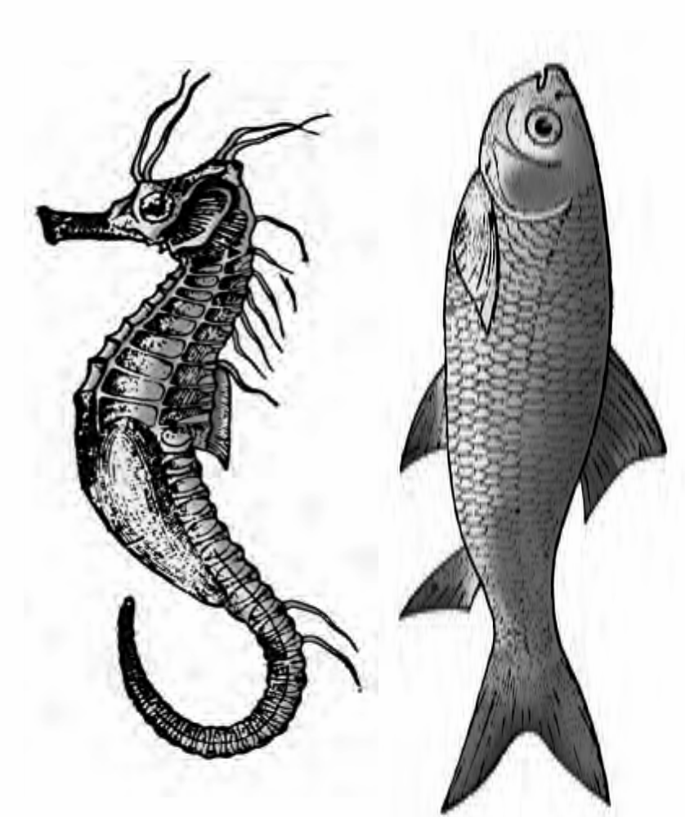
Fig. 4.20 - Bony fishes : (a) Hippocampus (b) Catla.
4.2.11.4 | Class - Amphibia

• As the name indicates (Gr., Amphi : dual, bios, life), amphibians can live in aquatic as well as terrestrial habitats (Figure 4.21). Most of them have two pairs of limbs. Body is divisible into head and trunk. Tail may be present in some.
• The amphibian skin is moist (without scales). The eyes have eyelids. A tympanum represents the ear. Alimentary canal, urinary and reproductive tracts open into a common chamber called cloaca which opens to the exterior.
• Respiration is by gills, lungs and through skin. The heart is three-chambered (two auricles and one ventricle). These are cold-blooded animals.
• Sexes are separate. Fertilisation is external. They are oviparous and development is indirect.
• Examples: Bufo (Toad), Rana (Frog), Hyla (Tree frog), Salamandra (Salamander), Ichthyophis (Limbless amphibia).
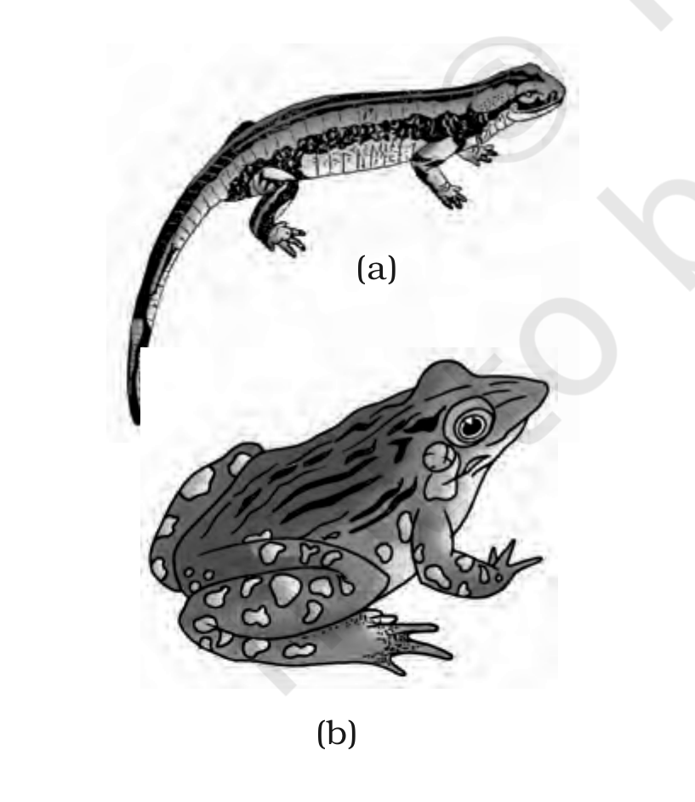
Fig. 4.21 - Examples of Amphibia : (a) Salamandra (b) Rana.
4.2.11.5 | Class - Reptilia

• The class name refers to their creeping or crawling mode of locomotion (Latin, repere or reptum, to creep or crawl). They are mostly terrestrial animals and their body is covered by dry and cornified skin, epidermal scales or scutes (Fig. 4.22).
• They do not have external ear openings. Tympanum represents ear. Limbs, when present, are two pairs; limbs are absent in snakes.
• Heart is usually three-chambered, but four-chambered in crocodiles. Reptiles are poikilotherms. Snakes and lizards shed their scales as skin cast.
• Sexes are separate. Fertilisation is internal. They are oviparous and development is direct.
• Examples: Chelone (Turtle), Testudo (Tortoise), Chameleon (Tree lizard), Calotes (Garden lizard), Crocodilus (Crocodile), Alligator (Alligator), Hemidactylus (Wall lizard); Poisonous snakes - Naja (Cobra), Bangarus (Krait), Vipera (Viper).
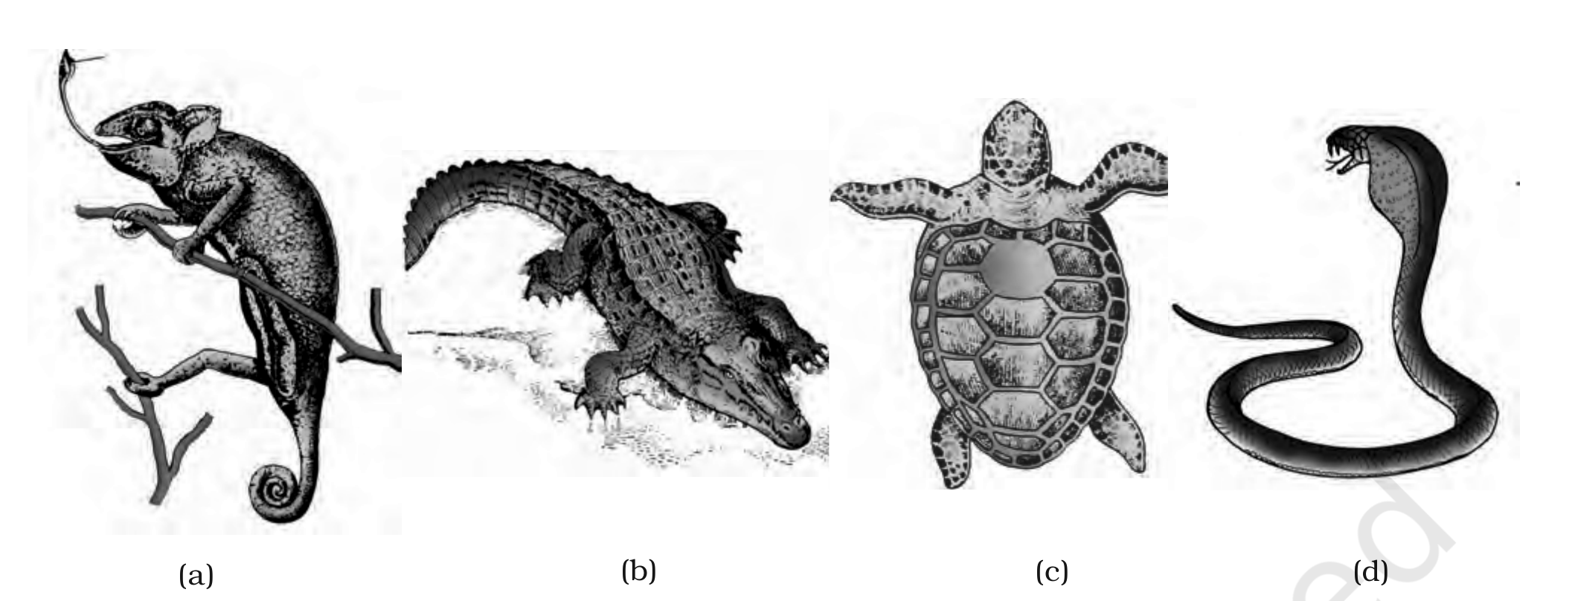
Fig. 4.22 - Reptiles : (a) Chameleon (b) Crocodilus (c) Chelone (d) Naja.
4.2.11.6 | Class - Aves

• The characteristic features of Aves (birds) are the presence of feathers and most of them can fly except flightless birds (e.g., Ostrich). They possess beak (Figure 4.23).
• The forelimbs are modified into wings. The hind limbs generally have scales and are modified for walking, swimming or clasping the tree branches. Skin is dry without glands except the oil gland at the base of the tail.
• Endoskeleton is fully ossified (bony) and the long bones are hollow with air cavities (pneumatic). The digestive tract of birds has additional chambers, the crop and gizzard. Heart is completely four-chambered.
• They are warm-blooded (homoiothermous) animals, i.e., they are able to maintain a constant body temperature. Respiration is by lungs. Air sacs connected to lungs supplement respiration.
• Sexes are separate. Fertilisation is internal. They are oviparous and development is direct.
• Examples: Corvus (Crow), Columba (Pigeon), Psittacula (Parrot), Struthio (Ostrich), Pavo (Peacock), Aptenodytes (Penguin), Neophron (Vulture).
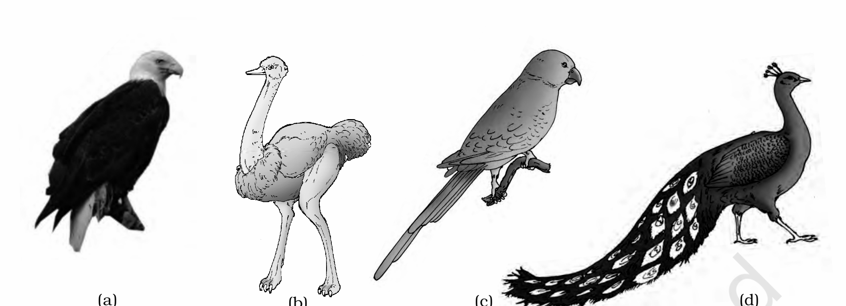
Fig. 4.23 - Some birds : (a) Neophron (b) Struthio (c) Psittacula (d) Pavo.
4.2.11.7 | Class - Mammalia

• They are found in a variety of habitats - polar ice caps, deserts, mountains, forests, grasslands and dark caves. Some of them have adapted to fly or live in water.
• The most unique mammalian characteristic is the presence of milk producing glands (mammary glands) by which the young ones are nourished. They have two pairs of limbs, adapted for walking, running, climbing, burrowing, swimming or flying (Figure 4.24).
• The skin of mammals is unique in possessing hair. External ears or pinnae are present. Different types of teeth are present in the jaw. Heart is four-chambered. They are homoiothermous. Respiration is by lungs.
• Sexes are separate and fertilisation is internal. They are viviparous with few exceptions and development is direct.
• Examples: Oviparous - Ornithorhynchus (Platypus); Viviparous - Macropus (Kangaroo), Pteropus (Flying fox), Camelus (Camel), Macaca (Monkey), Rattus (Rat), Canis (Dog), Felis (Cat), Elephas (Elephant), Equus (Horse), Delphinus (Common dolphin), Balaenoptera (Blue whale), Panthera tigris (Tiger), Panthera leo (Lion).
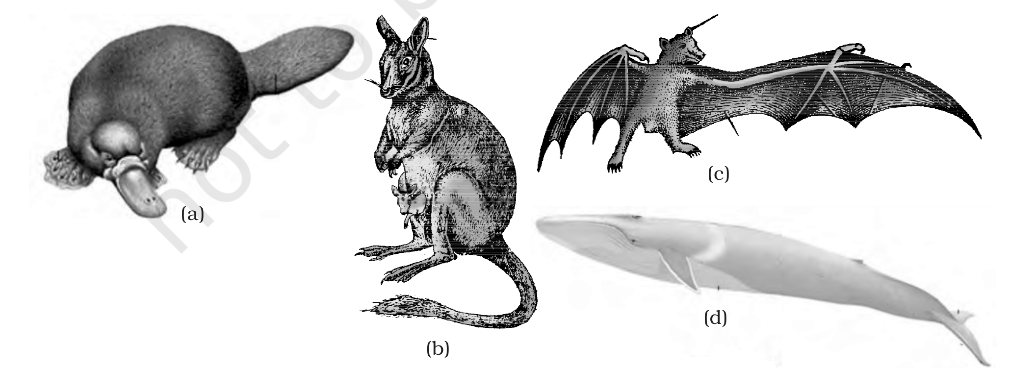
Fig. 4.24 - Some mammals : (a) Ornithorhynchus (b) Macropus (c) Pteropus (d) Balaenoptera.
The salient distinguishing features of all phyla under the animal kingdom are comprehensively given in Table 4.2.
TABLE 4.2 Salient Features of Different Phyla in the Animal Kingdom
Phylum | Level of Organisation | Symmetry | Coelom | Segmen-tation | Digestive System | Circula-tory | Respira-tory | Distinctive Features
Porifera | Cellular | Various | Absent | Absent | Absent | Absent | Absent | Body with pores and canals in walls.
Coelenterata (Cnidaria) | Tissue | Radial | Absent | Absent | Incomplete | Absent | Absent | Cnidoblasts present.
Ctenophora | Tissue | Radial | Absent | Absent | Incomplete | Absent | Absent | Comb plates for locomotion.
Platyhelminthes | Organ & Organ-system | Bilateral | Absent | Absent | Incomplete | Absent | Absent | Flat body, suckers.
Aschelminthes | Organ-system | Bilateral | Pseudo-coelomate | Absent | Complete | Absent | Absent | Often worm-shaped, elongated.
Annelida | Organ-system | Bilateral | Coelomate | Present | Complete | Present | Absent | Body segmentation like rings.
Arthropoda | Organ-system | Bilateral | Coelomate | Present | Complete | Present | Present | Exoskeleton of cuticle, jointed appendages.
Mollusca | Organ-system | Bilateral | Coelomate | Absent | Complete | Present | Present | External skeleton of shell usually present.
Echinodermata | Organ-system | Radial | Coelomate | Absent | Complete | Present | Present | Water vascular system, radial symmetry.
Hemichordata | Organ-system | Bilateral | Coelomate | Absent | Complete | Present | Present | Worm-like with proboscis, collar and trunk.
Chordata | Organ-system | Bilateral | Coelomate | Present | Complete | Present | Present | Notochord, dorsal hollow nerve cord, gill slits with limbs or fins.

Summary | Summary

The basic fundamental features such as level of organisation, symmetry, cell organisation, coelom, segmentation, notochord, etc., have enabled us to broadly classify the animal kingdom. Besides the fundamental features, there are many other distinctive characters which are specific for each phyla or class.
Porifera includes multicellular animals which exhibit cellular level of organisation and have characteristic flagellated choanocytes. The coelenterates have tentacles and bear cnidoblasts; they are mostly aquatic, sessile or free-floating. The ctenophores are marine animals with comb plates. The platyhelminths have flat body and exhibit bilateral symmetry; the parasitic forms show distinct suckers and hooks. Aschelminthes are pseudocoelomates and include parasitic as well as non-parasitic roundworms.
Annelids are metamerically segmented animals with a true coelom. The arthropods are the most abundant group of animals characterised by the presence of jointed appendages; the body is covered with external skeleton made of chitin. The molluscs have a soft body surrounded by an external calcareous shell. The echinoderms possess a spiny skin and their most distinctive feature is the presence of water vascular system. The hemichordates are a small group of worm-like marine animals with a cylindrical body of proboscis, collar and trunk.
Phylum Chordata includes animals which possess a notochord either throughout or during early embryonic life; other common features are the dorsal hollow nerve cord and paired pharyngeal gill slits. Some of the vertebrates do not possess jaws (Agnatha) whereas most of them possess jaws (Gnathostomata). Agnatha is represented by the class Cyclostomata; they are the most primitive chordates and are ectoparasites on fishes.
Gnathostomata has two super classes, Pisces and Tetrapoda. Classes Chondrichthyes and Osteichthyes bear fins for locomotion and are grouped under Pisces; the Chondrichthyes are fishes with cartilaginous endoskeleton and are marine. Classes Amphibia, Reptilia, Aves and Mammalia have two pairs of limbs and are thus grouped under Tetrapoda. The amphibians have adapted to live both on land and water. Reptiles are characterised by the presence of dry and cornified skin; limbs are absent in snakes. Fishes, amphibians and reptiles are poikilothermous (cold-blooded).
Aves are warm-blooded animals with feathers on their bodies and forelimbs modified into wings for flying; hind limbs are adapted for walking, swimming, perching or clasping. The unique features of mammals are the presence of mammary glands and hairs on the skin, and they commonly exhibit viviparity.
Exercises | Exercises

The exercises assume two term-pairs that the running text uses but never formally defines. They are stated here so the exercise set is self-contained.
• Intracellular vs extracellular digestion (Q4): in intracellular digestion food is broken down inside the cell (as in Porifera); in extracellular digestion food is broken down outside the cells in a gut cavity (coelenterates and ctenophores use both intracellular and extracellular digestion).
• Oviparous vs viviparous (Q12): oviparous animals lay eggs that develop and hatch outside the mother's body; viviparous animals give birth to young ones that have completed development inside the mother's body. The eggs of an oviparous mother and the young of a viviparous mother need not be equal in number.
[MEMORY AID - not in NCERT] Vertebrata ladder - Agnatha then Gnathostomata; within Gnathostomata, Pisces (Chondrichthyes, Osteichthyes) then Tetrapoda (Amphibia, Reptilia, Aves, Mammalia). Chamber count climbs 2 -> 3 -> (3/4) -> 4 -> 4 across fishes, amphibia, reptilia, aves and mammals.

